Project Development Phase

Model Performance Test

Model Performance Testing
S.No. | Parameter | Values | Screenshot
1 | Model Summary | AI-Enabled Student Admissions System developed on the Salesforce Platform using Salesforce Objects, Apex, Flows, Reports, and Agentforce AI. The system automates student registration, admission application processing, status tracking, AI-assisted query resolution, and report generation. | 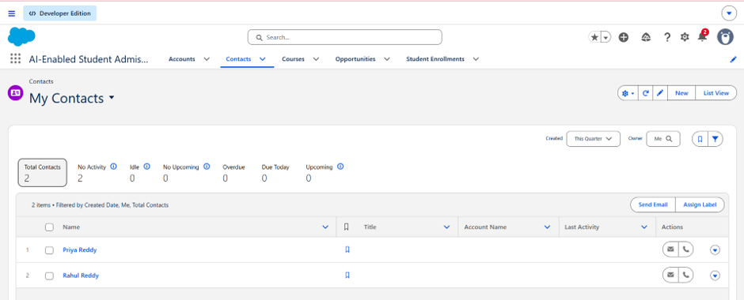
2 | Accuracy | Training Accuracy: Not Applicable (No custom ML model was trained.)  Validation Accuracy: Not Applicable (The project uses Salesforce Agentforce AI, a pre-trained AI service.) | 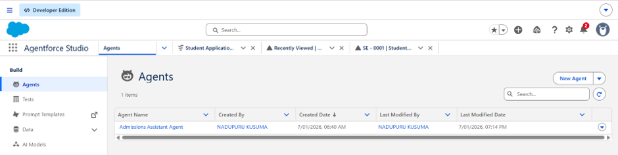
3 | Confidence Score / AI Response | Not Applicable (Confidence scores are applicable only to object detection models such as YOLO. This project uses Salesforce Agentforce AI for conversational assistance rather than custom object detection.) | 